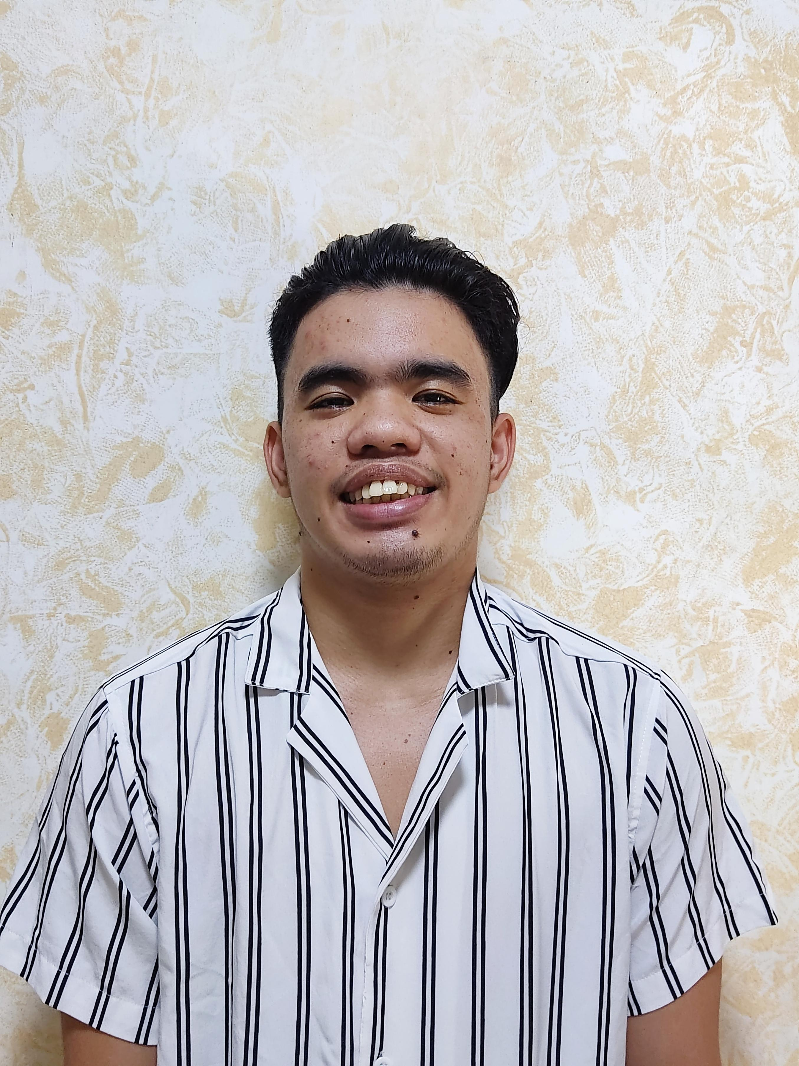John Vincent Del Rosario P.   
Indang Cavite

centvi1017@gmail.com  
09309213625

OBJECTIVE\* To gain more skills and knowledge.. Extra income that can help my studies

Educational Attainment  
  
National College Of Science and Technology  
City of Dasmarinas, Cavite  
Senior High School Student  
Graduates batch 2020-2021  
  
San nicolas Elementary school  
Dasmariñas, Cavite  
Elementary Graduated  
S.Y 2014-2015  
Currently 3rd year College

Course: Bachelor Of Arts English Language Studies

Attained Skills. Work experienced.  
  
-Good communication skill. Call center 1 year  
-basic accounting skills.

-Computer literate Factory worker 6 months

Sales and Inventory Encoder 6 months

PERSONAL PROFILE\*  
  
Date of Birth October 17,2001  
Age 21 years old  
Gender Male  
Weight 56 kg  
Height 5’4  
Civil Status Single  
Nationality Filipino  
FATHER’S NAME Fernando Del rosario

MOTHER’S NAME Parizza Perante